KONGARA SAI
192365025
CSA4308-INTERNET PROGRAMMING

16. ComplainEase is a robust online platform designed to streamline the process of
registering and managing complaints. The website allows users to easily submit
complaints by filling out a detailed form that includes categories, descriptions, and
supporting documents. Key functionalities include user registration and login,
real-time complaint tracking, and status updates via email or SMS. Users can view
their complaint history, receive feedback from resolution teams, and provide
additional information or evidence if needed. The platform also includes a search
feature for browsing common issues and solutions, and a dashboard for managing
and resolving complaints efficiently. ComplainEase aims to improve
responsiveness and transparency in handling user grievances, ensuring a smooth

INTERNET PROGRAMMING
LAB EXPRIMENTS

and effective resolution process.
USER
• Login
• Register
• Post Complaint
• Location Mark in Google Map
• View complaint status
• Feedback
• Get Admin Contact details
OFFICER
• Register
• Login
• View Complaint
• Update status
• Update proof of work
ADMIN
• Generate id & password for officer
• The administrator has full-fledged rights over the OES.
• Can create/delete an account.
• Can view the accounts.
• Can change the password.
• Can hide any kind of features from both of users.
• Insert the information of available on OES.
Can access all the accounts of the officer.
CODE:
<!DOCTYPE html>
<html>
<head>
<title>ComplainEase</title>
</head>
<body>
<h2>Complaint Registration</h2>

<form>
Name:<br>
<input type="text"><br><br>

Email:<br>
<input type="email"><br><br>

Category:<br>
<select>
<option>Road</option>
<option>Water</option>
<option>Electricity</option>
</select><br><br>

Description:<br>
<textarea rows="4" cols="30"></textarea><br><br>

Upload Proof:<br>
<input type="file"><br><br>

Location:<br>
<input type="text" placeholder="Google Map Location"><br><br>

<input type="submit" value="Submit Complaint">
</form>

<h3>Complaint Status</h3>
<p>Status: Pending</p>

<a href="#">Feedback</a><br>
<a href="#">Admin Contact</a>

</body>
</html>
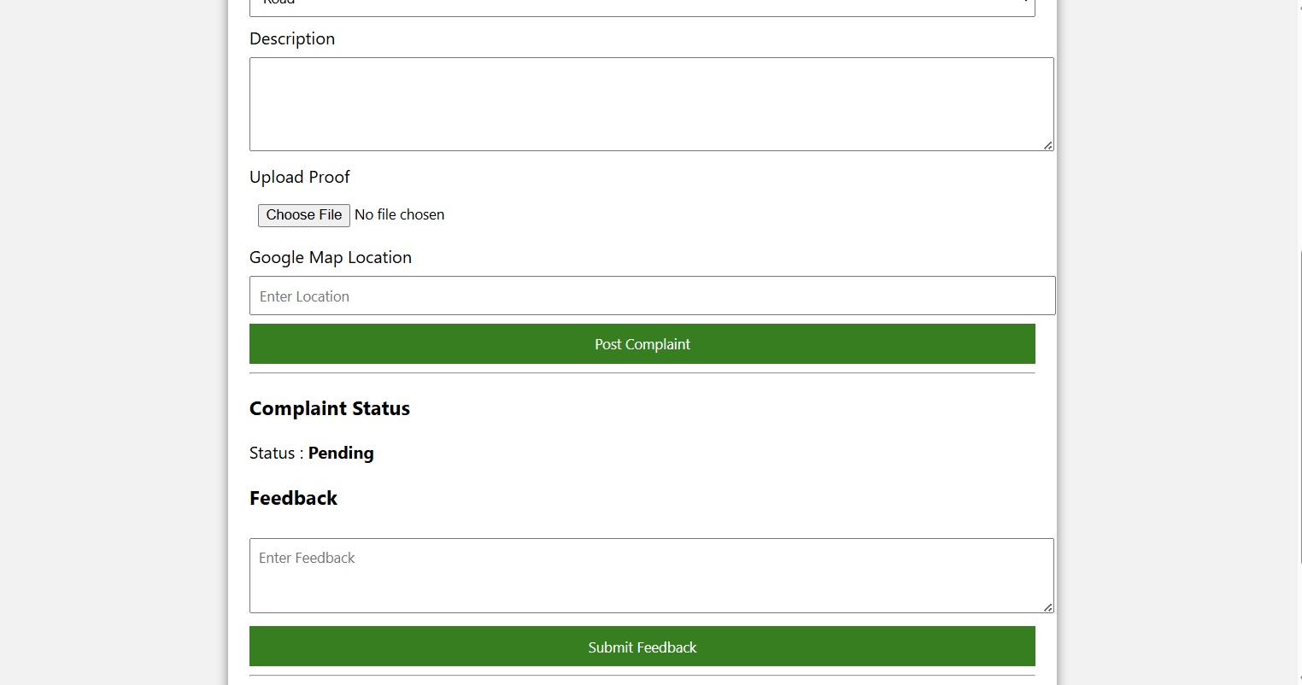

17. VoteOnline is a secure and user-friendly e-voting platform designed to facilitate and streamline
the voting process for elections. The website allows registered voters to log in and cast their
votes remotely, ensuring a seamless voting experience. Key functionalities include user
authentication with multi-factor verification, a list of candidates or referendum options with
detailed information, and a simple, intuitive voting interface. Voters can view their voting
history, receive confirmation of their submitted votes, and track the progress of the election in
real-time. The platform also provides secure data encryption to protect voter information and
ensures compliance with electoral regulations. VoteOnline aims to make the voting process
more accessible, efficient, and transparent, reducing barriers to participation and enhancing
election integrity
Admin
• Create Election Candidate
• Allocate election Data with Candidate
• Allocate user to election wards

INTERNET PROGRAMMING
LAB EXPRIMENTS

• Create Voter List
• Import Voter List
• View & update Voter List
• Get Election Results
USER
• Login using Voter ID
• OTP Login Verification
• Get OTP for Voting
• Select Candidate
• Submit Vote
<!DOCTYPE html>
<html>
<head>
<title>VoteOnline</title>
<style>
body{
font-family:Arial;
background:#f0f8ff;
margin:0;
}
header{
background:#004080;
color:white;
padding:15px;
text-align:center;
}
.container{
width:60%;
margin:auto;
background:white;
padding:20px;
margin-top:20px;
border-radius:10px;
box-shadow:0px 0px 10px gray;
}
input,select{
width:100%;
padding:8px;
margin:8px 0;
}
button{
width:100%;
padding:10px;
background:green;
color:white;
border:none;
cursor:pointer;
}
button:hover{
background:darkgreen;
}
footer{
background:#004080;
color:white;
text-align:center;
padding:10px;
margin-top:20px;
}
</style>
</head>
<body>

<header>
<h2>VoteOnline - E-Voting System</h2>
</header>

<div class="container">

<h3>Voter Login</h3>

<form>

<label>Voter ID</label>
<input type="text" placeholder="Enter Voter ID">

<label>Password</label>
<input type="password" placeholder="Enter Password">

<label>OTP Verification</label>
<input type="text" placeholder="Enter OTP">

<button type="button">Get OTP</button>

<br><br>

<label>Select Candidate</label>

<input type="radio" name="vote"> Candidate A <br>
<input type="radio" name="vote"> Candidate B <br>
<input type="radio" name="vote"> Candidate C <br>
<input type="radio" name="vote"> Candidate D <br><br>

<button type="submit">Submit Vote</button>

</form>

<hr>

<h3>Vote Confirmation</h3>
<p>Status : Your vote will be securely recorded.</p>

<hr>

<h3>Election Result</h3>
<p>Results will be announced after voting ends.</p>

</div>

<footer>
VoteOnline © 2026 | Secure Digital Voting
</footer>

</body>
</html>
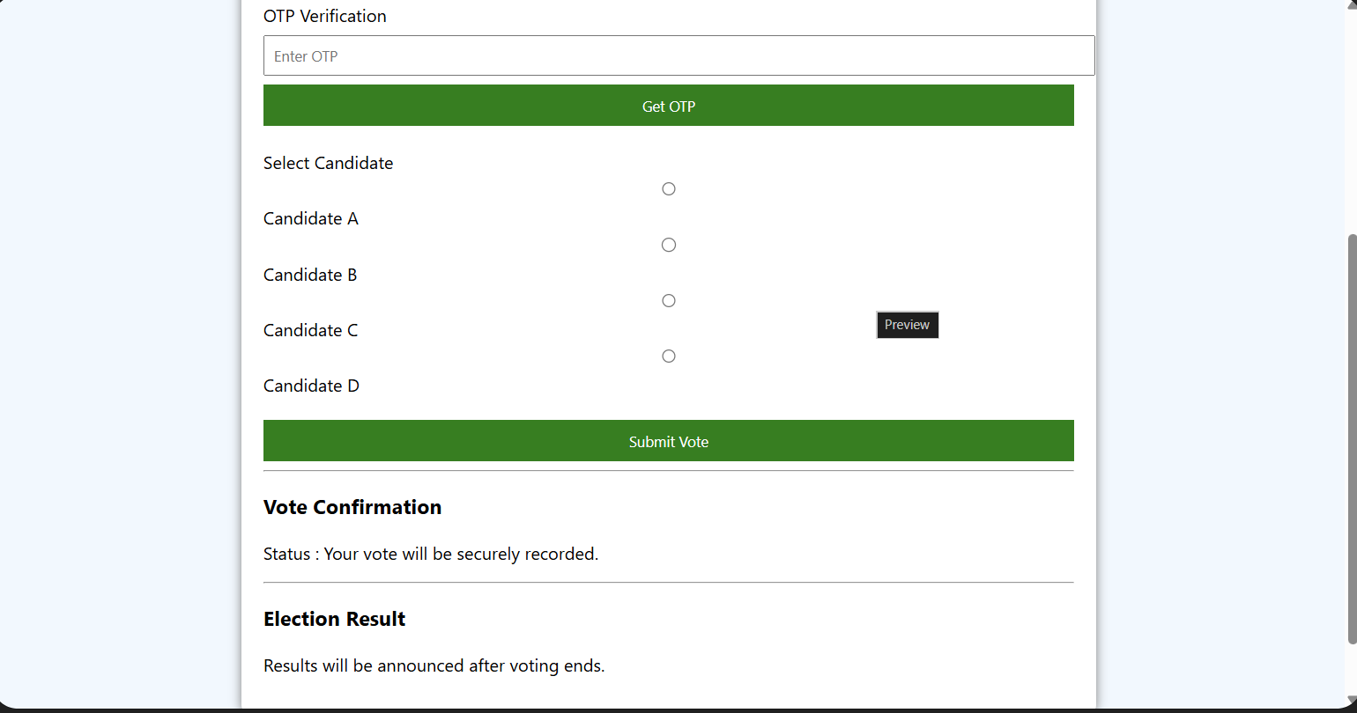

18. AgriMart is a comprehensive online platform catering to farmers and agricultural enthusiasts
with a wide range of products and services. The website features categories such as seeds,
fertilizers, pesticides, farming equipment, and tools. Key functionalities include user

registration and login, product search and filtering, detailed product descriptions, and high-
resolution images. Customers can place orders directly, track their shipments, and access

personalized recommendations based on their purchase history. The platform also offers secure
payment options and customer support for product inquiries and order issues. AgriMart aims
to provide a convenient and efficient shopping experience, helping users access essential
agricultural supplies and resources with ease.’
FARMER
• Login
• Register
• OTP Verification
• Manage Orders
• Update order Status
• Add Product
• Update/Delete product
• Upload images
• My Sales
• Update Shipping Status
• Logout

• Register
• Login
• OTP Verification
• My Account
• Manage Wallet Balance
• View product details
• Search product
• Add to cart
• Edit/Delete Cart
• Add/Edit Shipping Address
• Order Product
• My Order status
• View Shipping Status
<!DOCTYPE html>
<html>
<head>
<title>AgriMart</title>
<style>
body{
font-family:Arial;
background:#f4fff4;
margin:0;
}
header{
background:green;
color:white;
text-align:center;
padding:15px;
}
.container{
width:60%;
margin:auto;
background:white;
padding:20px;
margin-top:20px;
border-radius:10px;
box-shadow:0 0 10px gray;
}
input,select,textarea{
width:100%;
padding:8px;
margin:8px 0;
}
button{
width:100%;
padding:10px;
background:green;
color:white;
border:none;
cursor:pointer;
}
button:hover{
background:darkgreen;
}
img{
width:150px;
height:120px;
display:block;
margin:auto;
}
footer{
background:green;
color:white;
text-align:center;
padding:10px;
margin-top:20px;
}
</style>
</head>
<body>

<header>
<h2>AgriMart - Online Agriculture Store</h2>
</header>

<div class="container">

<img src="https://via.placeholder.com/150" alt="Product">

<form>

<label>Customer Name</label>
<input type="text" placeholder="Enter Name">

<label>OTP Verification</label>
<input type="text" placeholder="Enter OTP">

<label>Select Product</label>
<select>
<option>Seeds</option>
<option>Fertilizers</option>
<option>Pesticides</option>
<option>Farming Tools</option>
</select>

<label>Quantity</label>
<input type="number" placeholder="Enter Quantity">

<label>Shipping Address</label>
<textarea rows="3"></textarea>

<label>Wallet Balance</label>
<input type="text" value="₹1000" readonly>

<button type="button">Add to Cart</button>
<br><br>

<button type="submit">Order Product</button>

</form>

<hr>

<h3>Order Status</h3>
<p>Status : Processing</p>

<h3>Shipping Status</h3>
<p>Your order will be shipped soon.</p>

</div>

<footer>
AgriMart © 2026 | Smart Farming Solutions
</footer>

</body>
</html>
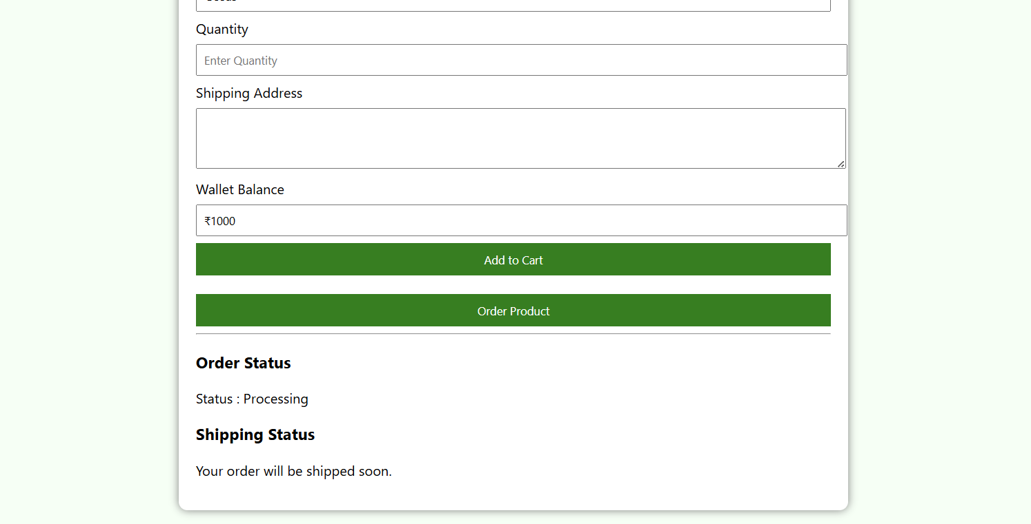

19. The farmer must send his animal’s signs and symptoms to doctor in video, audio, images
or text form. The doctor will receive the farmer’s requests and respond. The user’s data
will be automatically added to the database. The farmer has to register first and has to
subscribe. A farmer will freely subscribe to Govt. CVHs. He must pay a fee if he will
subscribe to the private clinic’s doctor. There will be two payment gateways for the
farmers, bank transfer (Doctor will provide his bank information while creating his
profile) and easy paisa. Doctors will provide their bank details for payments. He can also
provide easy paisa account details. There will be images of influenced animals with basic
diseases and their prescriptions. Based on recorded data, the system can perform an
analysis that which disease attacks on pets mostly in a specific area.
USER
• Register
• Login
• Post Complaint
• My Complaint Status
• View Vetcure details
• View News
• View Doctor
• View Report
• Post Feedback
• Make Payment
• My Profile
Doctor
• Register
• Login
• View Complaint
• Post Solution
• Manage Cure
• Manage news
• View user Details
• View Payment Details
• Feedback Details
CODE :
<!DOCTYPE html>
<html>
<head>
<title>VetCare Animal Health System</title>

<style>
body{
margin:0;
font-family:Verdana,sans-serif;
background:linear-gradient(to right,#16222A,#3A6073);
}
header{
background:#ff9800;
color:white;
padding:18px;
text-align:center;
font-size:28px;
}
.container{
width:60%;
margin:25px auto;
background:white;
padding:20px;
border-radius:12px;
box-shadow:0 0 15px black;
}
label{
font-weight:bold;
}
input,select,textarea{
width:100%;
padding:10px;
margin:8px 0;
border:1px solid #999;
border-radius:5px;
}
button{
width:100%;
padding:10px;
background:#ff9800;
color:white;
border:none;
font-size:16px;
cursor:pointer;
}
button:hover{
background:#e65100;
}
h3{
color:#0d47a1;
}
.status{
background:#e8f5e9;
padding:10px;
border-left:5px solid green;
margin-top:15px;
}
footer{
background:#ff9800;
color:white;
text-align:center;
padding:12px;
margin-top:20px;
}
</style>

</head>

<body>

<header>
<h2>🐄 VetCare - Animal Health Consultation</h2>
</header>

<div class="container">

<h3>Farmer Complaint Form</h3>

<form>

<label>Farmer Name</label>
<input type="text" placeholder="Enter Name">

<label>Animal Type</label>
<select>
<option>Cow</option>
<option>Goat</option>
<option>Dog</option>
<option>Chicken</option>
<option>Other</option>
</select>

<label>Symptoms</label>
<textarea rows="4" placeholder="Describe the symptoms"></textarea>

<label>Upload Image / Audio / Video</label>
<input type="file">

<label>Select Doctor</label>
<select>
<option>Government Doctor (Free)</option>
<option>Private Doctor (Paid)</option>
</select>

<label>Payment Method</label>
<select>
<option>Bank Transfer</option>
<option>Easy Paisa</option>
</select>

<button type="submit">Submit Complaint</button>

</form>

<div class="status">
<b>Complaint Status:</b> Waiting for Doctor Response
</div>

<h3>Doctor Contact</h3>
<p>Dr. Kumar | Mobile: 9876543210</p>

<h3>Latest News</h3>
<p>Free Vaccination Camp Available This Week.</p>

<h3>Feedback</h3>
<textarea rows="3" placeholder="Enter your feedback"></textarea>

<button>Send Feedback</button>

</div>

<footer>
VetCare © 2026 | Healthy Animals • Happy Farmers
</footer>

</body>
</html>
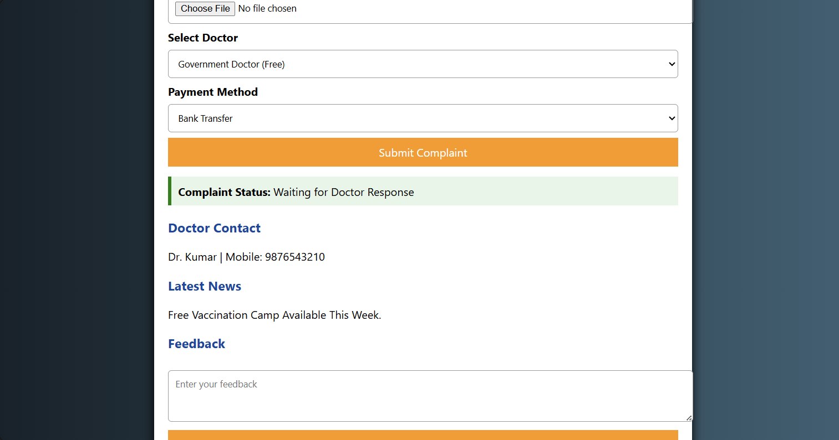

20. RentRide is a modern online platform designed for convenient vehicle rentals. The website
allows users to browse a diverse fleet of vehicles, including cars, trucks, and SUVs, based on
their needs and preferences. Key functionalities include user registration and login, a search
feature with filters for vehicle type, rental duration, and location, and detailed vehicle
descriptions with photos and pricing. Customers can book vehicles, manage their reservations,
and view rental history through a personalized dashboard. The platform supports secure
payment methods, provides real-time booking confirmations, and offers 24/7 customer support

for any rental issues. RentRide aims to simplify the vehicle rental process, ensuring a seamless
and efficient experience for users.Key Features
• Search Module
• Appointment Booking
• Check-in form Submitting
• Appointment management
• Schedule a timing
• Past appointment Management
• Reviews
Admin
• Login
• Add Vehicle
• Manage Vehicle details

o Type, Price, Etc
• Manage Booking details

o Approve User Booking
• My profile
User
• Register
• Login
• Search Vehicle details
• Select Vehicle & Make Booking
o Name, Customer No, Address, Type
• View Booking Status
• My profile
CODE:
<!DOCTYPE html>
<html>
<head>
<title>RentRide</title>

<style>
body{
margin:0;
font-family:Tahoma,sans-serif;
background:linear-gradient(135deg,#1a1a40,#6a11cb,#2575fc);
}
header{
background:#111;
color:#fff;
padding:18px;
text-align:center;
font-size:28px;
}
.container{
width:60%;
margin:30px auto;
background:#ffffff;
padding:20px;
border-radius:15px;
box-shadow:0 0 20px black;
}
h3{
color:#6a11cb;
}
label{
font-weight:bold;
}
input,select,textarea{
width:100%;
padding:10px;
margin:8px 0;
border-radius:6px;
border:1px solid gray;
}
button{
width:100%;
padding:12px;
background:#6a11cb;
color:white;
border:none;
font-size:16px;
cursor:pointer;
border-radius:6px;
}
button:hover{
background:#2575fc;
}
.status{
background:#f3e5ff;
padding:10px;
border-left:5px solid purple;
margin-top:15px;
}
footer{
background:#111;
color:white;
text-align:center;
padding:12px;
margin-top:20px;
}
</style>

</head>

<body>

<header>
🚗 RentRide - Vehicle Rental System
</header>

<div class="container">

<h3>Vehicle Booking</h3>

<form>

<label>Customer Name</label>
<input type="text" placeholder="Enter Name">

<label>Customer Mobile</label>
<input type="tel" placeholder="Enter Mobile Number">

<label>Address</label>
<textarea rows="2"></textarea>

<label>Select Vehicle</label>
<select>
<option>Car</option>
<option>Bike</option>
<option>SUV</option>
<option>Truck</option>
</select>

<label>Rental Date</label>
<input type="date">

<label>Schedule Time</label>
<input type="time">

<label>Rental Duration (Days)</label>
<input type="number">

<button type="submit">Book Vehicle</button>

</form>

<div class="status">
<b>Booking Status:</b> Waiting for Admin Approval
</div>

<h3>Customer Review</h3>
<textarea rows="3" placeholder="Write your review"></textarea>

<button>Submit Review</button>

</div>

<footer>
RentRide © 2026 | Safe • Fast • Affordable Rentals
</footer>

</body>
</html>
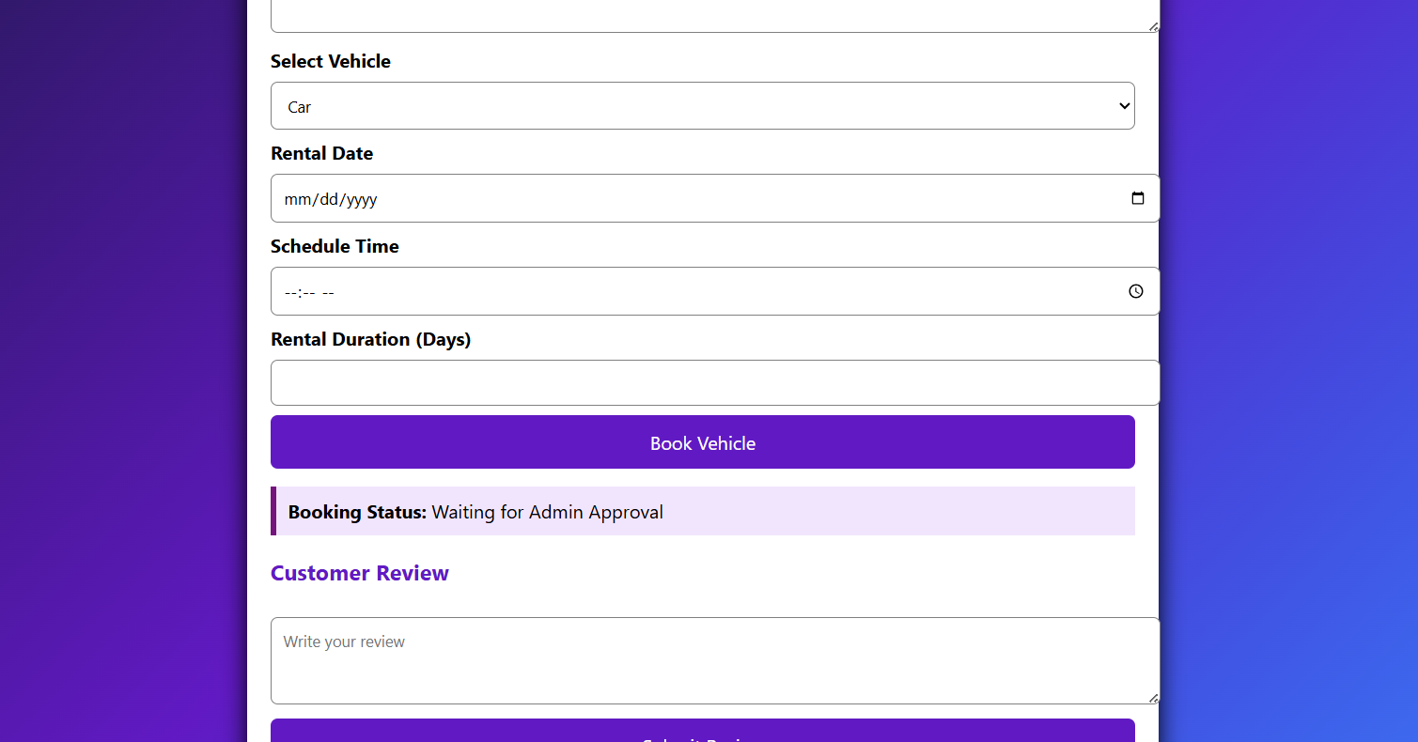
21. Applicants can browse through the vacancy details that are posted and can apply for the
jobs online. Director can browse through the posted resumes and select suitable
candidates. Filter, Search facility for User according to their required vacancy. Daily
updates via notifications andother communication media. Sending resume saves effort,
time and cost of user All vacanciesare available on a single interface user can set privacy
level for different companies’ user can save jobs according to their needs.
Admin
• Login
• Approve director
• View User
• View Report
Director
• Register

INTERNET PROGRAMMING
LAB EXPRIMENTS

• Login
• Post Vacancy
o Image, description, contact, etc
• View Vacancy
• View applied users
• Logout
User
• Register
• Login
• Search vacancy
• Filter by location wise, category.
• Apply for vacancy
• Logout
<!DOCTYPE html>
<html>
<head>
<title>Job Portal</title>

<style>
body{
margin:0;
font-family:Calibri,sans-serif;
background:linear-gradient(to right,#11998e,#38ef7d);
}
header{
background:#004d40;
color:white;
text-align:center;
padding:18px;
font-size:28px;
}
.container{
width:60%;
margin:25px auto;
background:white;
padding:20px;
border-radius:12px;
box-shadow:0 0 15px gray;
}
h3{
color:#00695c;
}
label{
font-weight:bold;
}
input,select,textarea{
width:100%;
padding:10px;
margin:8px 0;
border-radius:5px;
border:1px solid #999;
}
button{
width:100%;
padding:12px;
background:#00897b;
color:white;
border:none;
border-radius:5px;
font-size:16px;
cursor:pointer;
}
button:hover{
background:#00695c;
}
.info{
background:#e0f7fa;
padding:10px;
margin-top:15px;
border-left:5px solid #00897b;
}
footer{
background:#004d40;
color:white;
text-align:center;
padding:12px;
margin-top:20px;
}
</style>

</head>

<body>

<header>
💼 Online Job Portal
</header>

<div class="container">

<h3>Apply for a Job</h3>

<form>

<label>Applicant Name</label>
<input type="text" placeholder="Enter Your Name">

<label>Email</label>
<input type="email" placeholder="Enter Email">

<label>Job Category</label>
<select>
<option>Software Developer</option>
<option>Web Designer</option>
<option>Data Analyst</option>
<option>Marketing</option>
</select>

<label>Location</label>
<select>
<option>Chennai</option>
<option>Bangalore</option>
<option>Hyderabad</option>
<option>Coimbatore</option>
</select>

<label>Upload Resume</label>
<input type="file">

<label>Skills</label>
<textarea rows="3" placeholder="Enter Your Skills"></textarea>

<button type="submit">Apply Now</button>

</form>

<div class="info">
<b>Status:</b> Application Submitted Successfully.
</div>

<h3>Search Jobs</h3>
<input type="text" placeholder="Search Vacancy">

</div>

<footer>
Job Portal © 2026 | Find Your Dream Career
</footer>

</body>
</html>
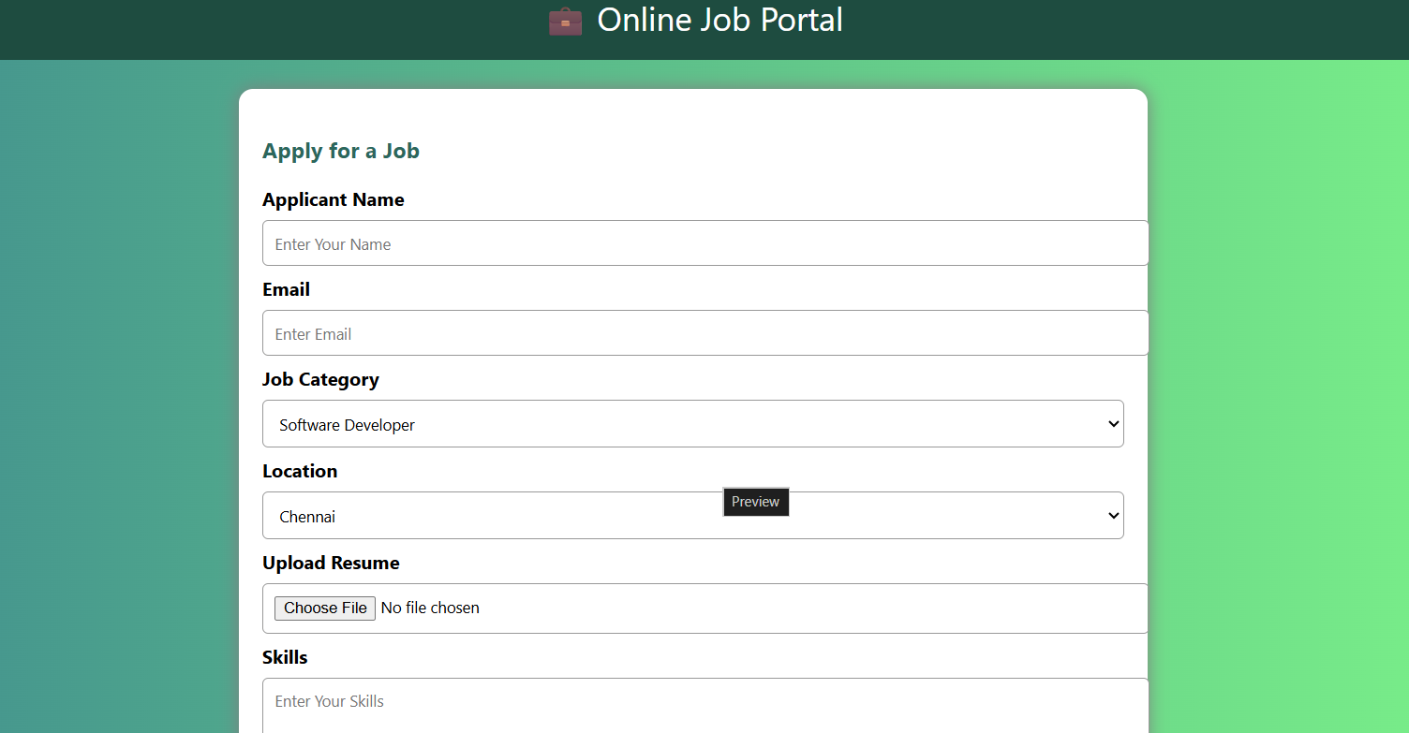
22. Solid waste management can be broadly categorized as segregation, collection, and
transportation. The server will collect the data and store them only a database. This data
will be analyzed and displayed on two different dashboards that can be accessed by
theworkforce and clients. Using data analytics, reports will be generated which can be
monitored by the admins through the admin dashboard. Based on the data collected,
garbage trucks can be given routes generated through various algorithms and google
maps API to efficiently route through all necessary garbage bins and finally reach the
dumping site Effective usage of dustbins.
Administrator
➢ Login
➢ Create Garbage bin
➢ Update/Delete garbage bin
➢ Assign best route for drivers
➢ Manage driver
➢ View Garbage Report
➢ View complaints from public
General Public
➢ Register
➢ Login
➢ Register complaint
➢ My complaint & status
Driver
➢ Login
➢ Check daily work updates
➢ Choose best route
➢ Update garbage load
CODE :
<!DOCTYPE html>
<html>
<head>
<title>Solid Waste Management</title>

<style>
body{
margin:0;
font-family:Arial,sans-serif;
background:linear-gradient(to right,#8B4513,#D2B48C);
}
header{
background:#5D4037;
color:white;
text-align:center;
padding:18px;
font-size:28px;
}
.container{
width:60%;
margin:25px auto;
background:white;
padding:20px;
border-radius:12px;
box-shadow:0 0 15px black;
}
h3{
color:#6D4C41;
}
label{
font-weight:bold;
}
input,select,textarea{
width:100%;
padding:10px;
margin:8px 0;
border:1px solid #999;
border-radius:5px;
}
button{
width:100%;
padding:12px;
background:#8D6E63;
color:white;
border:none;
border-radius:5px;
font-size:16px;
cursor:pointer;
}
button:hover{
background:#5D4037;
}
.status{
background:#FFF8E1;
padding:10px;
margin-top:15px;
border-left:5px solid #FFB300;
}
footer{
background:#5D4037;
color:white;
text-align:center;
padding:12px;
margin-top:20px;
}
</style>

</head>

<body>

<header>
🗑️ Solid Waste Management System
</header>

<div class="container">

<h3>Public Complaint Registration</h3>

<form>

<label>Name</label>
<input type="text" placeholder="Enter Your Name">

<label>Location</label>
<input type="text" placeholder="Enter Area">

<label>Complaint Type</label>
<select>
<option>Garbage Overflow</option>
<option>Dustbin Damage</option>
<option>Waste Collection Delay</option>
<option>Others</option>
</select>

<label>Complaint Description</label>
<textarea rows="3" placeholder="Enter Complaint"></textarea>

<label>Upload Image</label>
<input type="file">

<button type="submit">Submit Complaint</button>

</form>

<div class="status">
<b>Complaint Status:</b> Pending Verification
</div>

<h3>Driver Route</h3>
<p>Today's Route: Zone A → Zone B → Dumping Yard</p>

<h3>Garbage Load</h3>
<input type="text" placeholder="Update Garbage Load">

<button>Update Load</button>

</div>

<footer>
Solid Waste Management © 2026 | Clean City • Green City
</footer>

</body>
</html>
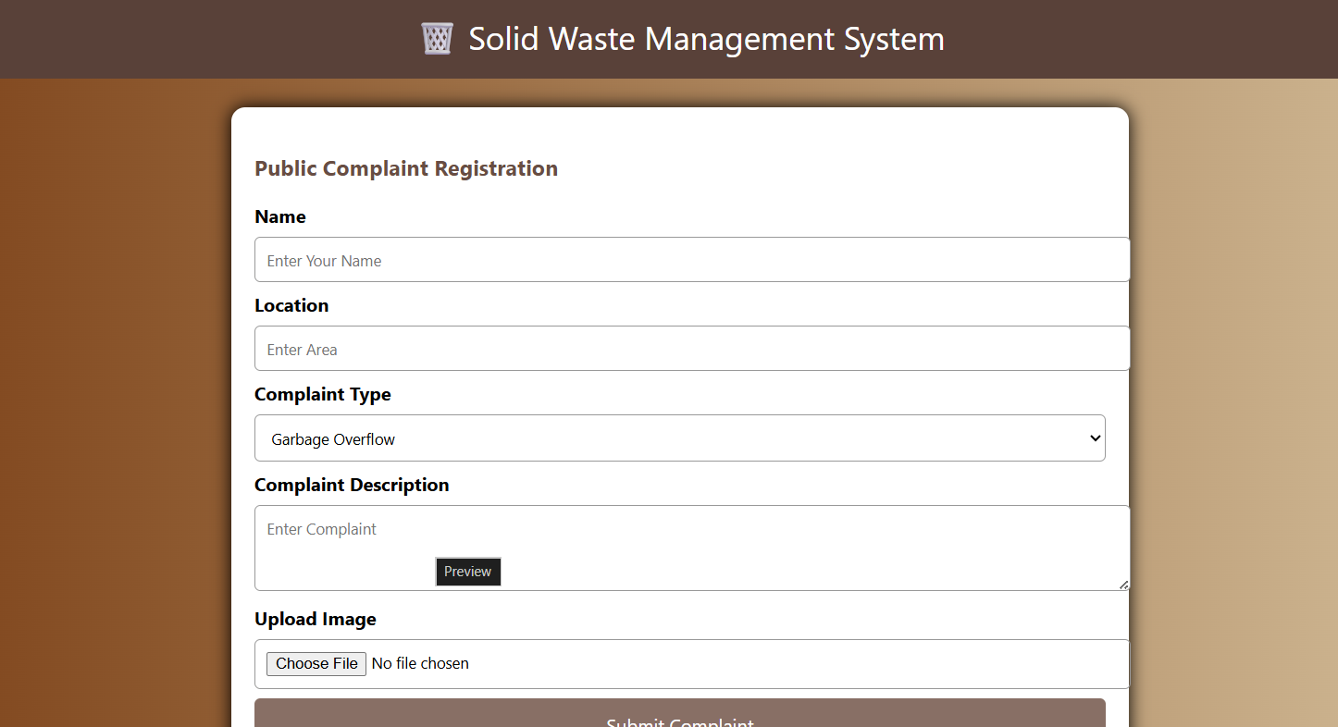
23. The blood management information system offers functionality to quick access to donor
records collected from various parts of the country. It enables monitoring of the results
and performance of the blood donation activity such that relevant and measurable
objectives of the organization can be checked. It provides to management timely,
confidential and securemedical reports that facilitates planning and decision making and
hence improved medical service delivery. The reports generated by the system give
answers to most of the challenges management faces as far as blood donor records are
concerned.
DONOR/USER
• Login
• Register
• Post Donar information
• My donar info
• Search donar details
• Search Blood bank details
• Logout
HOSPITAL
• Register
• Login
• Post Blood bank info
• Update blood group status
• View Blood bank details
• Logout
CODE:
<!DOCTYPE html>
<html>
<head>
<title>Blood Management System</title>

<style>
body{
margin:0;
font-family:Arial,sans-serif;
background:linear-gradient(to right,#ff416c,#ff4b2b);
}
header{
background:#8B0000;
color:white;
text-align:center;
padding:18px;
font-size:28px;
}
.container{
width:60%;
margin:25px auto;
background:white;
padding:20px;
border-radius:12px;
box-shadow:0 0 15px black;
}
h3{
color:#b71c1c;
}
label{
font-weight:bold;
}
input,select,textarea{
width:100%;
padding:10px;
margin:8px 0;
border:1px solid #999;
border-radius:5px;
}
button{
width:100%;
padding:12px;
background:#d32f2f;
color:white;
border:none;
border-radius:5px;
font-size:16px;
cursor:pointer;
}
button:hover{
background:#b71c1c;
}
.info{
background:#ffebee;
padding:10px;
margin-top:15px;
border-left:5px solid red;
}
footer{
background:#8B0000;
color:white;
text-align:center;
padding:12px;
margin-top:20px;
}
</style>

</head>

<body>

<header>
🩸 Blood Management Information System
</header>

<div class="container">

<h3>Donor Registration</h3>

<form>

<label>Donor Name</label>
<input type="text" placeholder="Enter Name">

<label>Blood Group</label>
<select>
<option>A+</option>
<option>A-</option>
<option>B+</option>
<option>B-</option>
<option>AB+</option>
<option>AB-</option>
<option>O+</option>
<option>O-</option>
</select>

<label>Phone Number</label>
<input type="tel" placeholder="Enter Mobile Number">

<label>City</label>
<input type="text" placeholder="Enter City">

<label>Hospital / Blood Bank</label>
<input type="text" placeholder="Enter Blood Bank Name">

<button type="submit">Register Donor</button>

</form>

<div class="info">
<b>Donor Status:</b> Successfully Registered
</div>

<h3>Search Blood Bank</h3>
<input type="text" placeholder="Search Blood Bank">

<h3>Search Donor</h3>
<input type="text" placeholder="Search by Blood Group">

<button>Search</button>

</div>

<footer>
Blood Management System © 2026 | Donate Blood ❤️ Save Life
</footer>

</body>
</html>
